Design and Dev iteration No. 1

Project title: Crafty Canvas

**1. A design iteration. Complete levels 1, 2, and 3 of the https://c4model.com/**

## Software Architectural Diagram

## 1. System Context diagram

## 

## 2. Container diagram

## 

## 3. Component diagram

## 

**3. List down the FRs which you will have implemented by the end of the semester. This can be the same list as in your last submission, but I am asking for it again because some of you have updated FRs (just write down range or list of FRs) - everyone should do this, even the Ebryx groups need to give me a target in some form if not a list of FRs**

**Functional Requirements**

* **FR1: User Registration**
* **Description**: The system shall allow user registration and authentication functionality, enabling users to create accounts using their email or social media profiles, with password reset options.
* **Actor**: Artists and Clients (User)
* **Precondition**: The user is not registered in the system.
* **Postcondition**: The user is registered in the system and directed to the login screen.
* **Details**:

1. Users can provide a valid email address and password.
2. The system validates the email format and ensures it is unique.
3. User account information is securely stored in the database.

* **FR2: User Login**
* **Description:** The system shall provide a user login feature, enabling registered users (Artists and Clients) to access their accounts by entering valid credentials.
* **Actor:** Users (Artists and Clients)
* **Precondition:** The user is registered in the system.
* **Postcondition:** The user is successfully logged into the system and directed to their personalized dashboard.
* **Details:**

1. Users navigate to the login page.
2. Users input a valid email address and password.
3. The system validates the entered credentials.
4. If the credentials are valid, the user is logged in, and the system redirects them to their personalized dashboard.
5. If the credentials are invalid, the system displays an error message, prompting the user to re-enter the correct information.

* **FR3: Create Profile**
* **Description:** The system shall support profile creation functionality, allowing new users (both Artists and Clients) to establish their presence on the platform.
* **Actor:** Users (Artists and Clients)
* **Precondition:** The user is not registered in the system.
* **Postcondition:** The user successfully creates a profile, and the profile information is stored in the system.
* **Details:**

1. Users initiate the profile creation process.
2. The system prompts users to provide registration information, including a valid email address and password.
3. The system validates the email format and ensures it is unique.
4. Upon successful validation, the system creates a user account for the artist or client.
5. Users are prompted to complete their profiles by providing additional information such as name, address, and other relevant details.
6. Users have the option to upload a profile picture.
7. The user confirms the provided information, and the system saves their profile.
8. Upon profile creation, the system may send a welcome email to the user.

* **FR4: Edit Profile**
* **Description:** The system shall have user profile management features, allowing users to edit and update their profiles, including personal information, profile pictures, and other details.
* **Actor:** Artists and Clients (User)
* **Precondition:** The user is logged into the system.
* **Postcondition:** User profile information is updated.
* **Details:**

1. Users can edit and update their personal information, including name, address, and contact information.
2. Users can change their profile pictures.
3. Users can update other profile details, such as a bio, preferences, and display settings.

* **FR5: User Profile Management**
* **Description**: The system shall have user profile management features that includes allowing users to edit and update their profiles, including personal information and profile pictures.
* **Actor**: Artists and Clients (User)
* **Precondition**: The user is logged into the system.
* **Postcondition**: User profile information is updated.
* **Details**:

1. Users can edit and update their personal information.
2. Users can upload and change their profile pictures.

* **FR6: User Password Reset**
* **Description:** The system shall offer user password reset functionality, allowing users to reset forgotten passwords for account access.
* **Actor:** Users
* **Precondition:** Users forget their passwords.
* **Postcondition:** Users can reset their passwords for account access.
* **Details:**

1. Users can initiate the password reset process.

* **FR7: Artist Profile Support**
* **Description**: The system shall facilitate artist profiles, enabling artists to create detailed profiles showcasing their portfolio, a bio, and contact information.
* **Actor**: Artists
* **Precondition**: The artist is registered in the system.
* **Postcondition**: Artist profile is created and visible to other users.
* **Details:**

1. Artists can create detailed profiles with portfolio information.
2. Artists can provide a biography and contact information.

* **FR8: Product Listings**
* **Description**: The system shall facilitate product listings, permitting artists to add artworks with titles, descriptions, prices, and multiple images.
* **Actor**: Artists
* **Precondition**: The artist is registered in the system.
* **Postcondition**: Artwork listings are created and visible to users.
* **Details**:

1. Artists can create listings for artworks with titles and descriptions.
2. Artists can specify prices for their artworks.
3. Multiple images of the artwork can be uploaded.

* **FR9: Artwork Search and Filter**
* **Description:** The system shall allow users to search and filter artworks, facilitating easy discovery through keywords, categories, and artist names, with refined search options.
* **Actor:** Buyers
* **Precondition:** The user is logged into the system.
* **Postcondition:** Users has discovered relevant artworks through search and filters.
* **Details:**

1. Users can search for artworks using keywords, categories, and artist names.
2. Users can apply refined search filters to narrow down results.

* **FR10: Real-time Chat**
* **Description:** The system shall include real-time chat functionality, facilitating instant communication between clients and artists for customization requests, price negotiations, and progress tracking.
* **Actor:** Users (Clients and Artists)
* **Precondition:** Users are logged into the system.
* **Postcondition:** Users can engage in real-time chat conversations.
* **Details:**

1. Users can engage in real-time chat with other users.
2. Chat supports text, images, and possibly video messages.

* **FR11: Bidding/Price Negotiation System**
* **Description:** The system shall have a bidding/price negotiation system, enabling artists to set base prices and clients to place bids, leading to price negotiations.
* **Actor:** Users (Clients and Artists)
* **Precondition:** Users are interested in purchasing artworks.
* **Postcondition:** Price negotiations can take place.
* **Details:**

1. Artists can set base prices for their artworks.
2. Clients can place bids on artworks.
3. Price negotiations are facilitated.

* **FR11.1: Artwork Base Price Setting**
* **Description:** The system shall allow artists to set a base price for their artworks when creating listings.
* **Actor:** Artists
* **Precondition:** The artist is registered in the system.
* **Postcondition:** The base price for the artwork is set and visible to potential buyers.
* **Details:**

1. Artists can specify a base price when creating artwork listings.
2. The base price serves as the starting point for price negotiations with potential buyers.

* **FR11.2: Client Bid Placement**
* **Description:** The system shall permit clients to place bids on artworks listed by artists.
* **Actor:** Clients
* **Precondition:** The client is interested in purchasing an artwork.
* **Postcondition:** The bid is placed on the artwork, and the artist is notified.
* **Details:**

1. Clients can view artwork listings and choose to place a bid.
2. Clients specify the bid amount they are willing to pay for the artwork.
3. The system records the bid and notifies the artist of the bid.

* **FR11.3: Accepting/Rejecting Bids**
* **Description:** The system shall provide the option for artists to accept or reject client bids.
* Actor: Artists
* **Precondition**: A client has placed a bid, and price negotiations have occurred.
* **Postcondition:** The artist either accepts or rejects the client's bid, and the client is notified of the decision.
* **Details:**

1. Artists can review the negotiations and the client's bid.
2. Artists have the option to accept the bid, finalizing the sale, or reject the bid, indicating a decision not to proceed with the sale.
3. The system notifies the client of the artist's decision.

* **FR11.4: Bid Expiry and Auto-Cancellation**
* **Description:** The system shall automatically cancel client bids if the artist does not respond within a specified time frame.
* **Actor:** System
* **Precondition:** A client has placed a bid, and the artist has not responded within the specified time frame.
* **Postcondition:** The bid is automatically canceled, and the client is notified.
* **Details:**

1. The system sets a specified time frame for artist response.
2. If the artist does not accept or reject the bid within the specified time, the system automatically cancels the bid.
3. The system notifies the client of the bid cancellation.

**Bidding wireframes**

***(From Buyers perspective)***

**This is the gallery of the website, where all the artworks are displayed including artworks with fixed and bidding prices.**

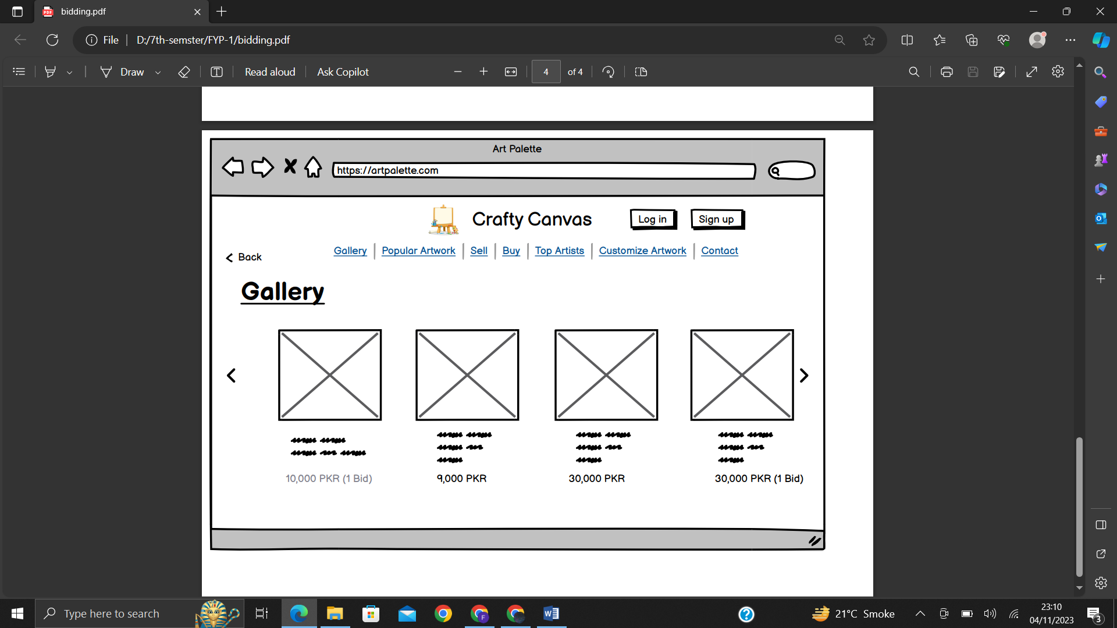

**This page will open once you select the artwork with bidding price. The buyer will select the price of the bid from the drop down option. The place max bid option will allow the buyer to let the artist know how much they want to bid in their painting.**

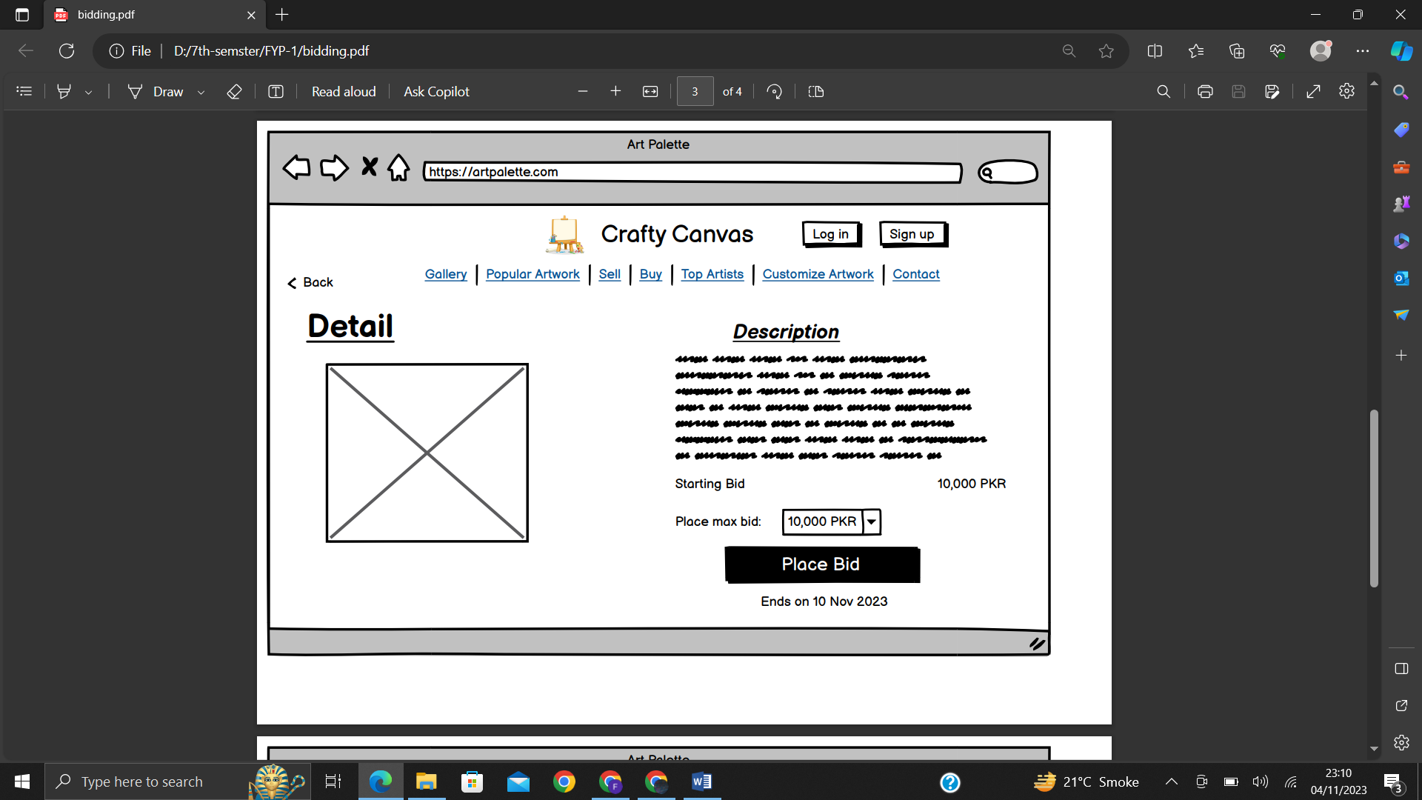

**This page will open once you select the Place bid option. The buyer have to enter their full name, city , address, state and the number of any of the two accounts i.e. Jazzcash or EasyPaisa.**

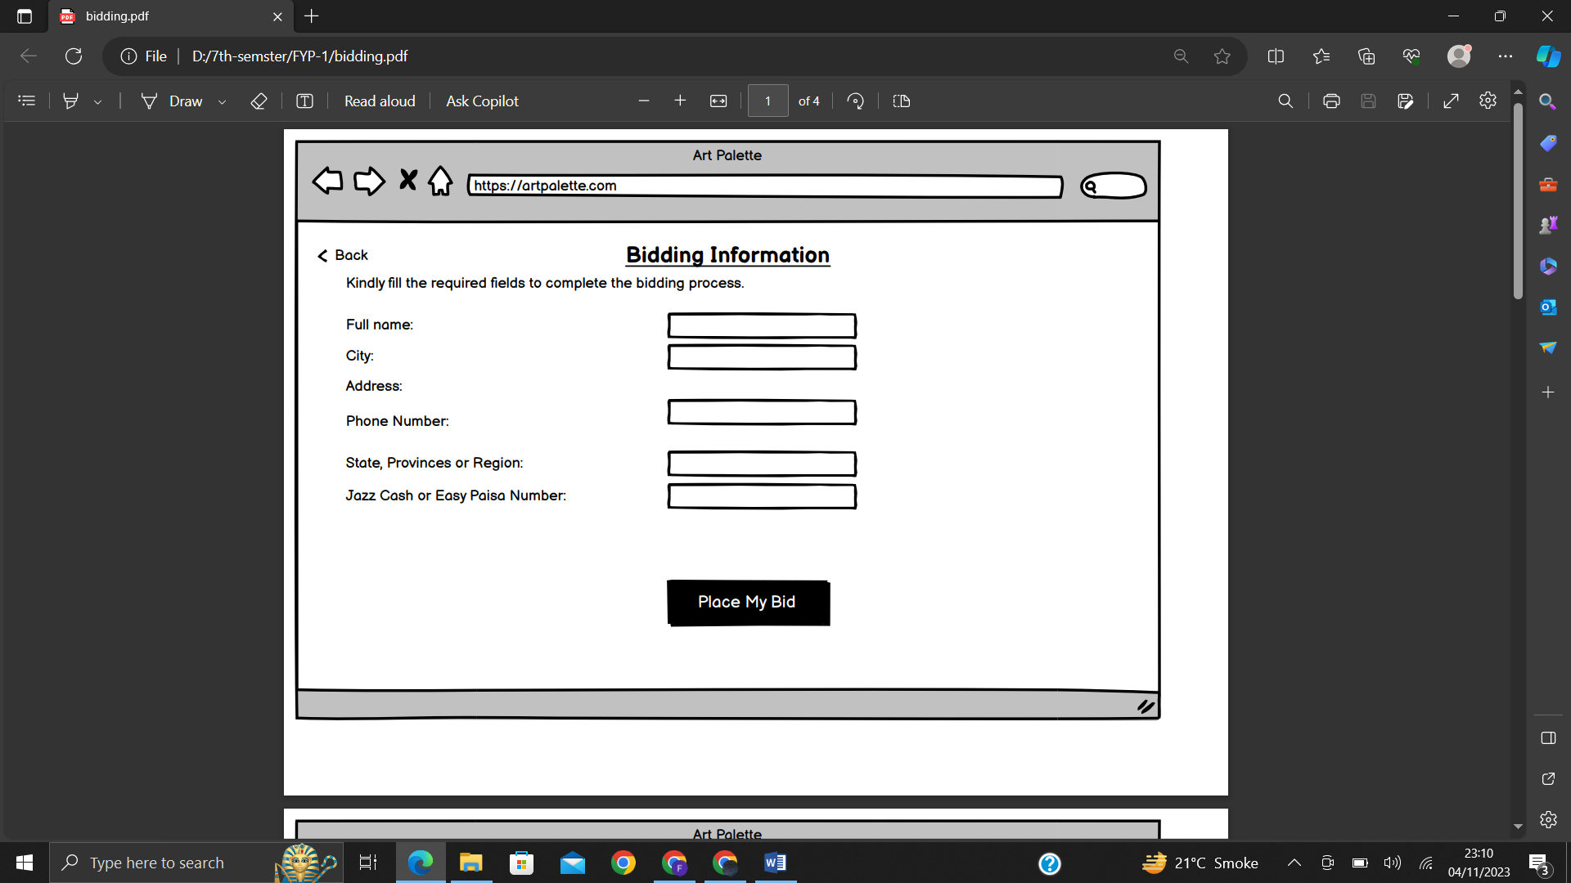

**This page will open once you select the Place my bid option. Firstly the bid will be confirmed by the artist and then it will be displayed on the painting.**

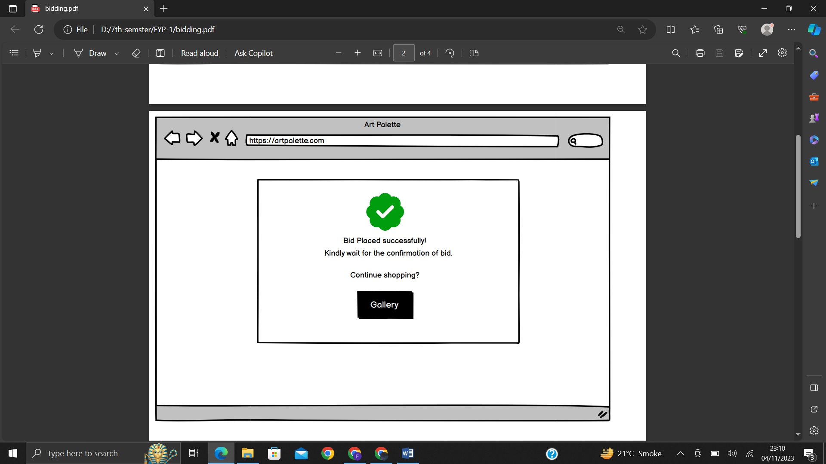

***(From Sellers/artist perspective)***

**The artist/seller will firstly select the add new button to upload a new artwork.**

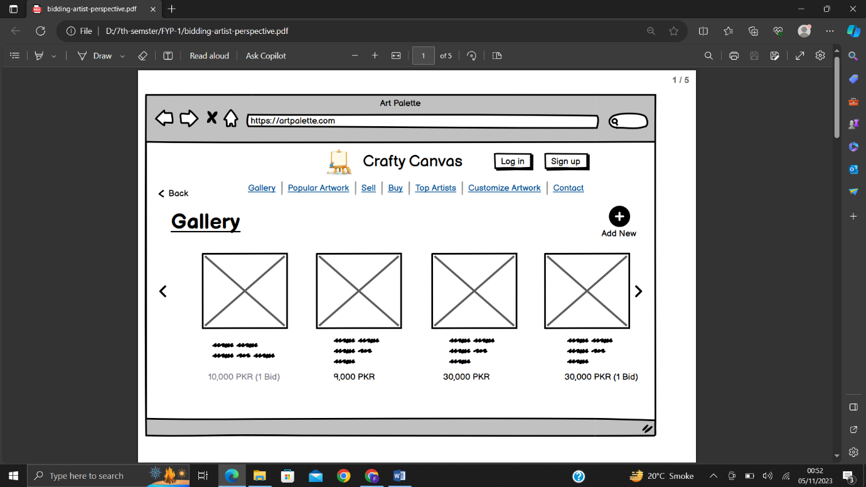

**When the artist/seller selects the add new button, a form will appear in which they have to fill the detail about the artwork they are selling. The prices will be in the form of fixed price or bidding.**

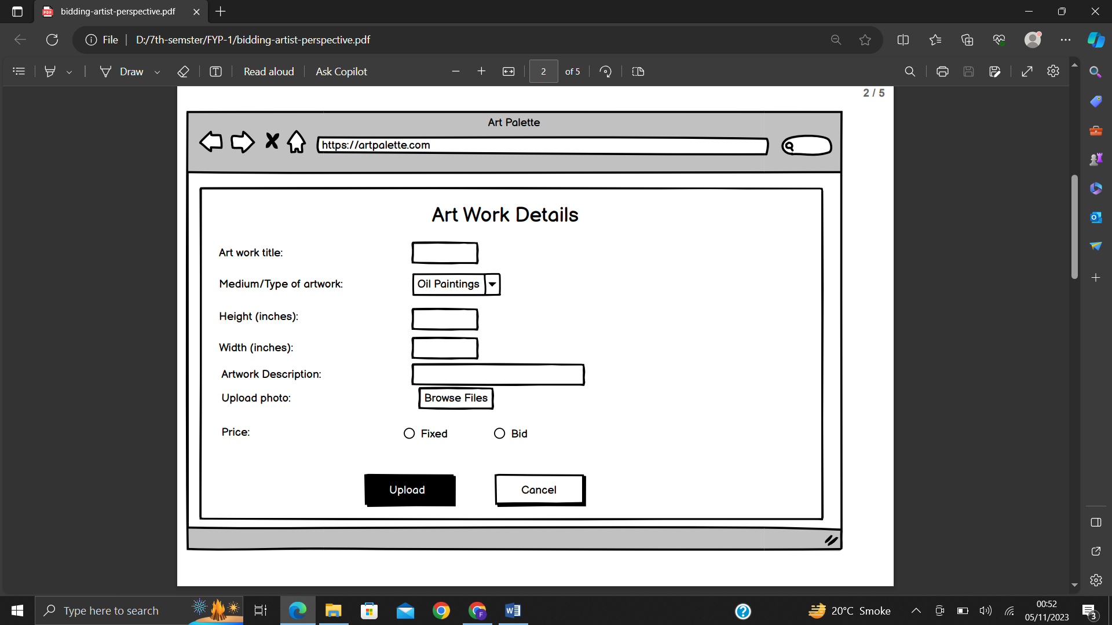

**If the artist/seller wants to keep the price fixed they will select the fixed option and state the price.**

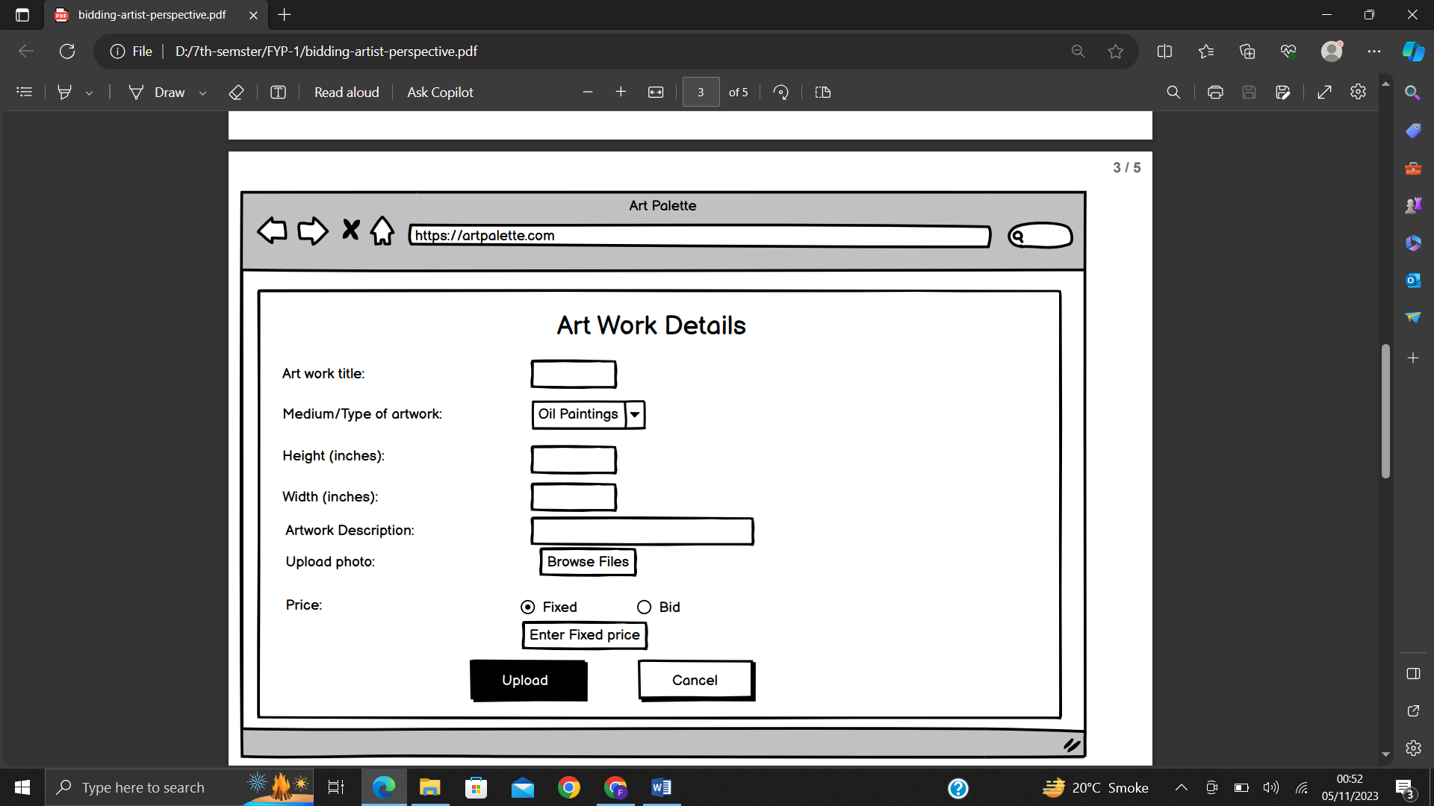

**If the artist/seller wants to bid on the artwork they can select the bid option and then state the starting bid. The bid can be of any amount.**

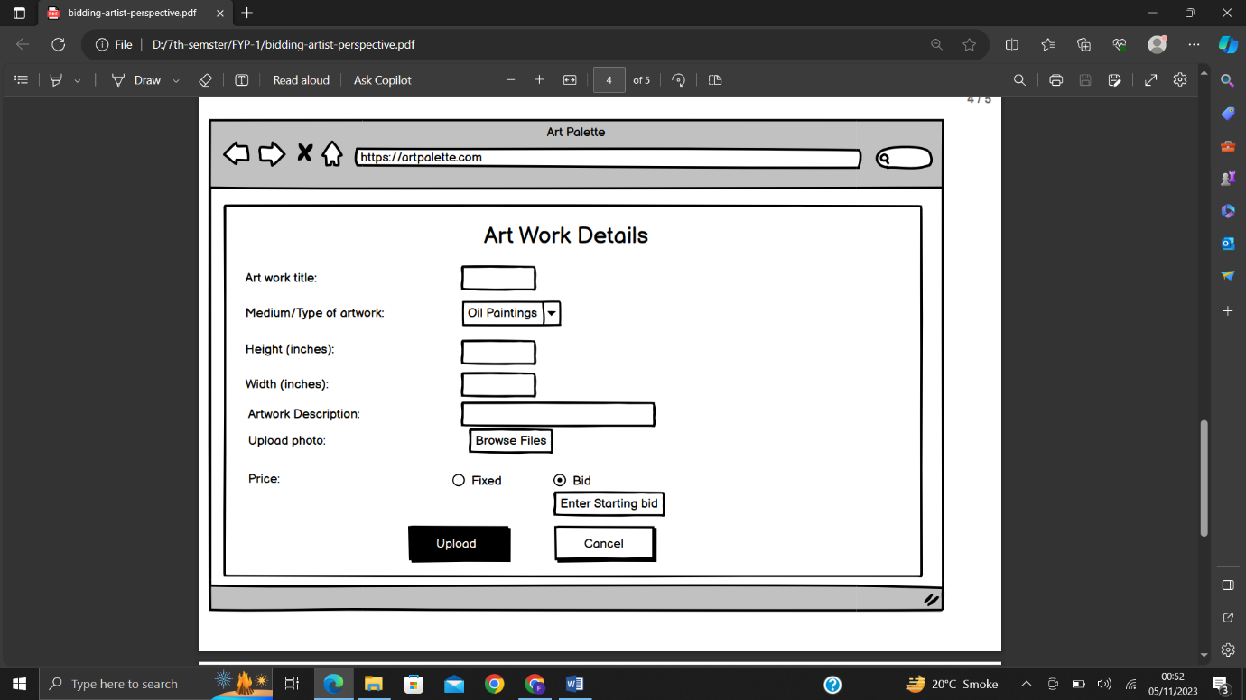

**Lastly, when the price method is finalized the artist/seller can upload the artwork.**

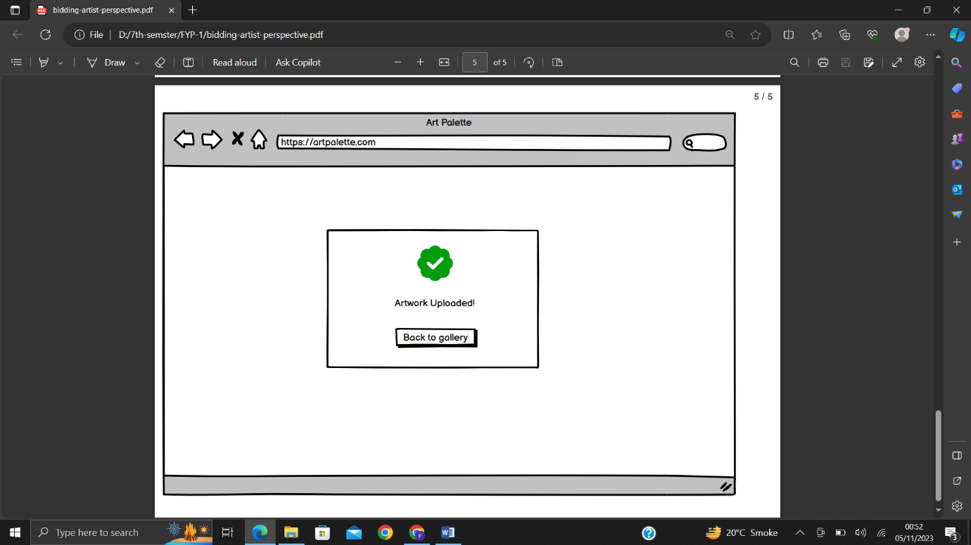

* **FR12: Secure Payment Processing**
* **Description:** The system shall integrate secure payment processing, with trusted payment gateways like Jazz Cash or Easy Paisa.
* **Actor:** Users (Clients)
* **Precondition:** Users are ready to make a purchase.
* **Postcondition:** Payment is securely processed.
* **Details:**

1. The system integrates trusted payment gateways.
2. Various payment methods, such as credit cards or mobile wallets, are supported.

* **FR13: Order Management**
* **Description:** The system shall provide the above mentioned order management capabilities, allowing users to access their order history and artists to monitor commissioned orders, updating clients on progress.
* **Actor:** Users (Clients and Artists)
* **Precondition:** Users have made or received orders.
* **Postcondition:** Users can track the progress and status of their orders.
* **Details:**

1. Users can view their order history.
2. Artists can monitor the status of commissioned orders.
3. Clients receive updates on the progress of their orders.

* **FR14: Return and Refund Requests**
* **Description:** The system shall facilitate return and refund requests, allowing clients to initiate requests for damaged or misrepresented artworks, with a record of such requests.
* **Actor:** Users (Clients)
* **Precondition:** Clients receive damaged or misrepresented artworks.
* **Postcondition:** Users can initiate return and refund requests.
* **Details:**

1. Clients can initiate return and refund requests.
2. Records of such requests are maintained for reference.

* **FR15: User Notifications**
* **Description:** The system shall send user notifications, including email and in-app alerts for events like new messages, bid updates, and order status changes.
* **Actor:** Users (Clients and Artists)
* **Precondition:** Relevant events occur (e.g., new messages, bid updates).
* **Postcondition:** Users receive notifications for relevant events.
* **Details:**

1. Users receive notifications for various events through email and in-app alerts.

* **FR16: Artwork Reviews**
* **Description:** The system shall enable artwork reviews, with clients able to leave reviews and ratings for purchased artworks, visible on artist profiles and listings.
* **Actor:** Users (Clients)
* **Precondition:** Users have purchased artworks.
* **Postcondition:** Artwork reviews and ratings are displayed.
* **Details:**

1. Clients can leave reviews and ratings for purchased artworks.
2. These reviews and ratings are visible on artist profiles and artwork listings.

* **FR17: Intellectual Property Protection**
* **Description:** The system shall support intellectual property protection, allowing artists to watermark their artwork images to safeguard against unauthorized use.
* **Actor:** Artists
* **Precondition:** Artists want to protect their artwork from unauthorized use.
* **Postcondition:** Artists can watermark their artwork images.
* **Details:**

1. Artists can add watermarks to their artwork images to protect them.

* **FR18: User Feedback and Improvement**
* **Description:** The system shall encourage user feedback and continuous improvement, collecting user/artists suggestions to meet evolving users and artist’s needs.
* **Actor:** Users
* **Precondition:** Users want to provide feedback and suggestions.
* **Postcondition:** User feedback is collected and considered for system improvement.
* **Details:**

1. Users can provide feedback and suggestions for system improvement.

* **FR19: Admin Panel**
* **Description:** The system will have an admin panel, enabling monitoring and management of user accounts, listings, and reported issues, with the authority to address policy violations.
* **Actor:** Admin
* **Precondition:** Admin access the admin panel.
* **Postcondition:** Admin can monitor and manage user accounts, listings, and issues.
* **Details:**

1. The admin panel allows system administrators to manage user accounts.
2. Admin can oversee and address reported issues.
3. The admin panel provides the authority to address policy violations.

* **FR20: Secure File Uploads**
* **Description:** The system shall ensure file uploads, with scans for malware and copyright issues, ensuring the safety and quality of uploaded files.
* **Actor:** Users (Artists)
* **Precondition**: Artists upload files to the system.
* **Postcondition:** Uploaded files are scanned for security and quality.
* **Details:**

1. The system scans uploaded files for malware and copyright issues.
2. Ensures the safety and quality of uploaded files.

* **FR21: Help Centre and User Support**
* **Description:** The system shall provide a help center and user support, offering assistance, answers to common questions, and prompt issue resolution. In case of any issue, user can directly contact the admin through a contact information provided on the website such as email or phone number.
* **Actor:** Users
* **Precondition:** Users require assistance or have questions.
* **Postcondition:** Users receive assistance and issue resolution.
* **Details:**

1. The system offers a help centre with answers to common questions.
2. User support is available for prompt issue resolution.

* **FR22: User Profile Editing and Updates**
* **Description:** The system shall facilitate user profile editing and updates, enabling users to modify personal information, profile pictures, and other details.
* **Actor:** Users
* **Precondition:** Users want to update their profiles.
* **Postcondition:** User profile information is updated.
* **Details:**

1. Users can edit and update their personal information.
2. Users can change their profile pictures and other profile details.

* **FR23: Listing Details**
* **Description:** The system shall include listing details, displaying information such as the date of creation and the number of views to provide transparency about artwork history and popularity.
* **Actor:** Users
* **Precondition:** Users view artwork listings.
* **Postcondition:** Users have access to additional information about artworks.
* **Details:**

1. Listing details include the date of creation and the number of views for transparency.

* **FR24: Artwork Customization**
* **Description:** The system shall support customization of artworks, allowing clients to request specific modifications or personalized elements on selected artworks before making a purchase.
* **Actor:** Users (Clients and Artists)
* **Precondition:** The user is logged into the system, and the selected artwork is available for customization.
* **Postcondition:** The requested artwork customization details are communicated to the artist, and the client is notified of the customization process.
* **Details:**

1. Clients can select an artwork available for customization.
2. The system shall provide a customization interface where clients can specify their customization requirements (e.g., color changes, size adjustments).
3. Clients can add specific instructions or comments related to the customization.
4. The customization details are securely stored and associated with the selected artwork.
5. Artists receive notifications about customization requests and can review the client's specifications.
6. Artists can communicate with clients to discuss customization details or seek clarification.
7. Once the customization is agreed upon, artists update the artwork accordingly, and clients are notified of the completion.
8. Clients can review the customized artwork and proceed with the purchase if satisfied.

**Non-Functional Requirements**

1. The user interface shall have a modern and visually appealing design to enhance user engagement.
2. The system shall be optimized for mobile devices, providing a seamless and visually pleasing experience across various screen sizes.
3. The system shall have Filters and sorting options accessible, allowing users to refine searches and discover artworks efficiently.
4. The real-time chat feature shall have minimal latency, providing instant communication between users.
5. Users shall be able to edit and update their profiles with minimal effort, using a straightforward and user-friendly interface.
6. Transitions between different screens and pages within the system shall be smooth, providing a visually pleasing and coherent user journey.
7. The Artists shall receive notifications of customization requests promptly, ensuring timely communication with clients.

**4. Note down the minutes of any meetings you have with advisors (internal and external; if you have an assigned external, you must have one meeting per week). The minutes can be noted down in point form.**

we do not have external advisors assigned to our team. However, we've been proactively seeking valuable insights and guidance from various sources.  
 we came across a comprehensive YouTube video that provided an excellent walkthrough on implementing login and registration functionality in the MERN stack. The content was insightful, and we believe it will greatly contribute to the success of our project.

Link of the video is:

https://youtu.be/ZVyIIyZJutM?si=l1NTQvpzDy2cwJ05

**5. Note down the work done by each group member.**

**a. Group member 1**

* Faarha has completed the software architectural diagram, outlining the overall structure and components of our software system.
* Fiza will be responsible for designing and implementing the login page and secure authentication process.
* Hamza is tasked with handling both the signup functionality and establishing the connection to the database and proper data storage.